Law ethics and responsible disclosure:

**Responsible disclosure:** geheimhoud verklaring

Etchis is moraal

Law: cybercrime covers

Illegal acces

Illegal interception

Data interference

System interference

Misuse of devices

Computer related forgery

Computer related fraud

Offences related to child pornography

Offences related to copyright

**Relevant legislation:**

Law: Dutch laws

4 catogories: see powerpoint

1. employees

2. diefstal

3. spionage, exame fraud.

4. terrorists, ddos

Cato 1: hacking into a (social media) account or (corporate) server

Change passwords/in

Alle uitspraken in de rechtbank worden opgeslagen. Dus als je wilt opzoeken wat voor straf je zou krijgen voor een cybercrime, dan kan je dat opzoeken.

Cato 2: of theft with false key and computer breach, consisting of logging into a bank account and then transferring money to the account of third partys, with login details wich the offender was not entitled. Usually the login details are obtained through phishing and/or malware.

Internet banking theft maakt onderscheid tussen bedragen dat gestolen worden.

Have maleware/passwords/login details

Use of crypto and ransomeware

Cato 3: defaces website, ddos attack with limited impact.

Computer ethics whats the difference between law and ethics

**Computer ethics**.

Computer ethics is a part of practical philosophy concerned with how computing professionals should make decisions

Ethics: 10 commands:

Thou shalt not use a computer to harm other people.

**Disclosures:**

**Non-disclosure:** is a principle that no vulnerability information should be shared, or should only be shared under non-disclosure agreement (either contractually or informally).

Common proponents of non-disclosure include commercial exploit vendors, researchers who intend to exploit the flaws they find, proponents of security through obscurity.

Een bedrijf wil niet dat de rest van de wereld weet dat er een vulnerability was.

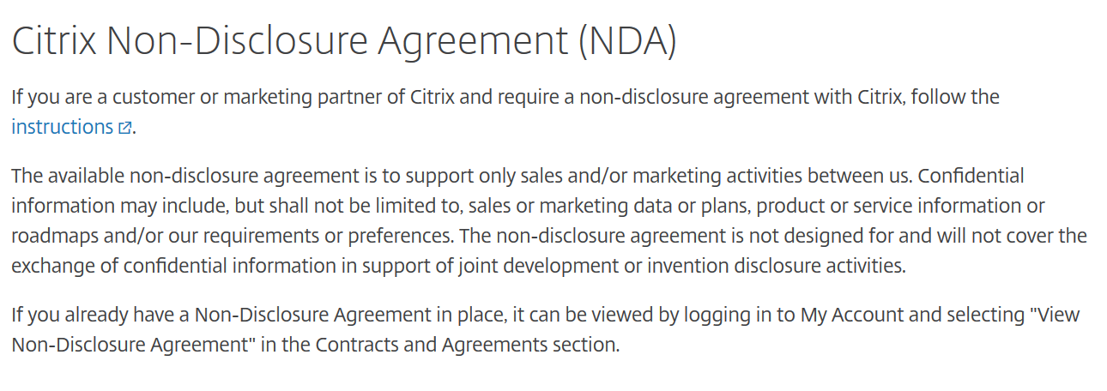

[**https://www.citrix.com/about/legal/nda.html**](https://www.citrix.com/about/legal/nda.html)

**Responsible disclosure:** een bank heeft dit.

In computer security or elsewehere, responsible disclosure is a vulnerability disclosure model in which a vulnerability or an issue is disclosed only after a period of time that allows for the vulnerability or issue to

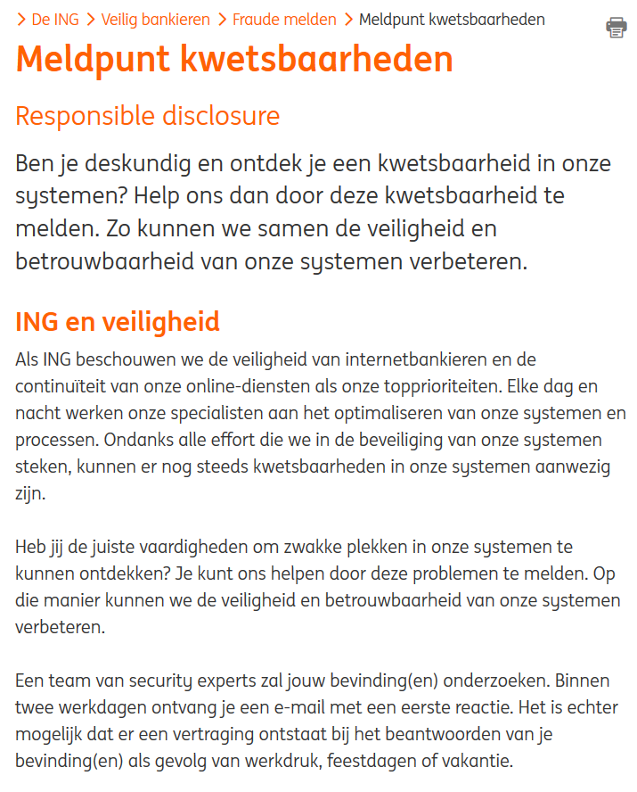

<https://www.ing.nl/de-ing/veilig-bankieren/fraude-melden/meldpunt-kwetsbaarheden/index.html>

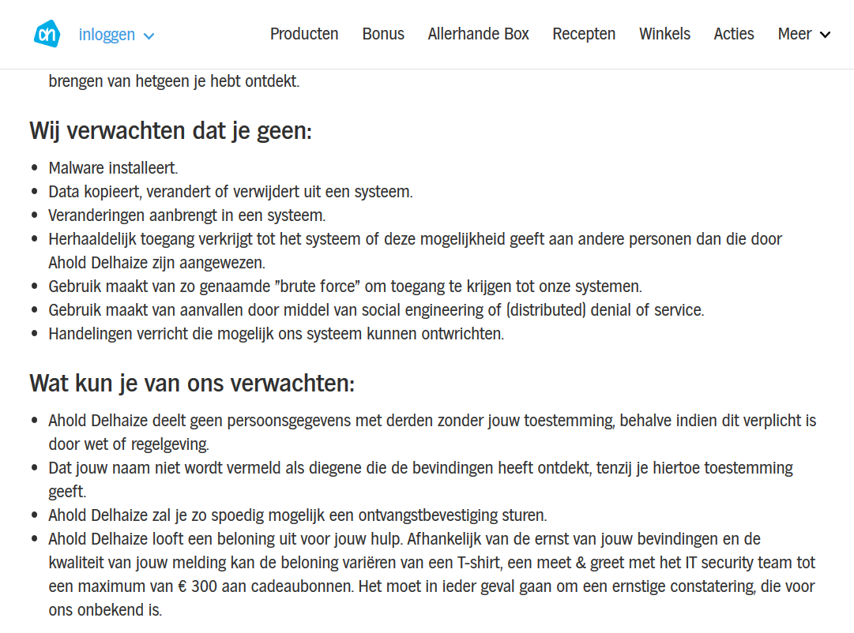https://www.ah.nl/kwetsbaarheid-melden

**Full disclosure:**

Is the practice of publishing analysis of software vulnerabilities as early as possible, making the data accessible to everyone without restriction. The primary purpose of widely disseminating information about vulnerabilities is so that potential victims are as knowledgeable as those who attack them.

**SQL injection:**

Van user input tot een sql query

SELECT * FROM users WHERE naam=’guest’ wachtwoord=‘12345’

SELECT FROM users WHER naam=’guest’ and wachtwoord=’geenidee' OR '1' = '1

Soms == of soms =

SQL injection special chars

‘ ; --

Afhankelijk van de database (mysql, sql server, oracle)

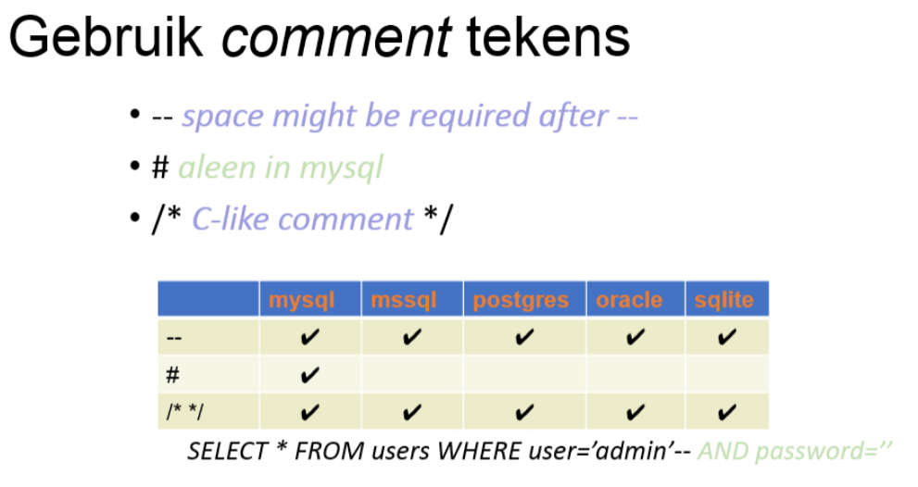

Gebruik van union all statement voor toegang tot data van andere tabellen.

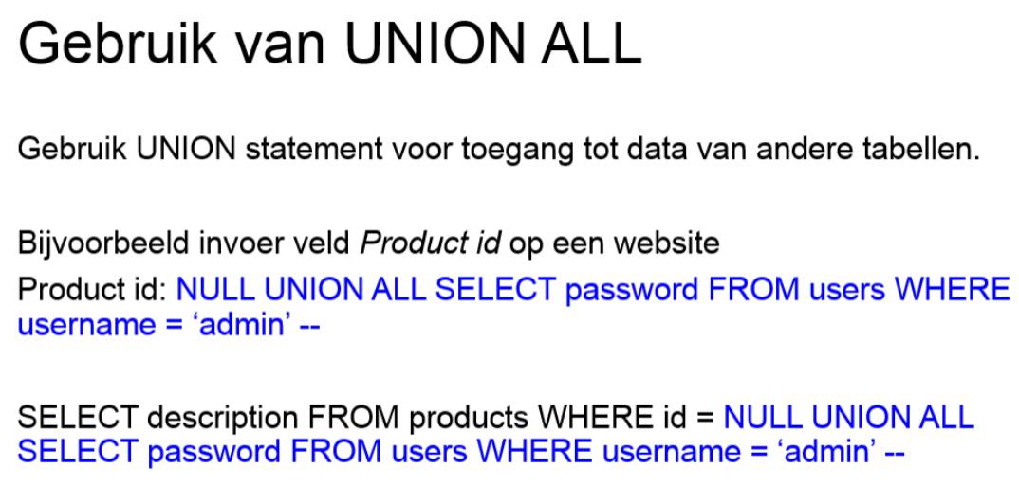

Blindfolded sql injection structuur van een database uitvinden en vindt de versie van de database.

IdL 123 ORDER BY 2

Ophogen 2 tot error of andere response kan aantal kolommen in tabel weergeven

Metadata database opvragen bijv schema

Id